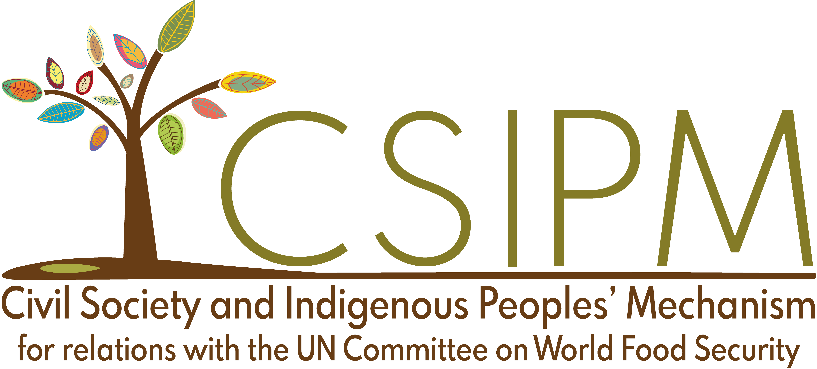

FOR IMMEDIATE RELEASE

Food sovereignty is not possible without financial sovereignty, warn small-scale food producers and grassroots organisations

Rome, Italy. 16 April 2025. Faced with a global financial system that undermines the right to food and food sovereignty, civil society and Indigenous Peoples' organisations called on governments to strengthen public policies and financing that favour local food production, to guarantee transparency and effective accountability mechanisms, and to ensure the active participation of small-scale producers in the design, monitoring and evaluation of these policies.

Brought together through the Civil Society and Indigenous Peoples' Mechanism (CSIPM) during the Collaborative Governance Dialogue of the UN Committee on World Food Security (CFS), the organisations stated clearly: there can be no food sovereignty without financial sovereignty.

Small-scale food producers, responsible for the bulk of the food consumed on the planet, face poverty, discrimination, shrinking landholdings,  lack of access to credit, markets and infrastructures, and marginalisation from the spaces where public policies are defined. All these constraints operate within the framework of a global financial system that prioritises profit over people.

In 2023, more than 3.3 billion people lived in countries that allocated more resources to paying interest on foreign debt than to health or education. Morgan Ody, peasant and general coordinator of La Vía Campesina, explained how policies imposed by creditors and international financial institutions force governments to prioritize export-oriented production while relying on imports to feed their populations, generating a dangerous dependence on volatile markets and greater exposure to global crises such as those of 2008 or 2022.

‘We’re not against international aid, but it must not create new forms of dependency,’ she added. Governments must channel resources towards public policies that strengthen local food production. For example, through agrarian reform programmes to guarantee the right to land, market regulation policies or agroecological transition. Developing a fair tax system and directing more national public investment to infrastructure and public services are also key.

‘All the necessary solutions to support sustainable finance and support small-scale food producers exist, they are there. All that is needed is political will to put them into practice’, denounced Ibrahima Coulibaly, peasant and president of the Pan-African Farmers’ Organization, and ROPPA. In the case of Africa, he warned, governments  don’t fulfil their commitment to dedicate at least 10% of the national budget to agriculture, and only 6% of farmers have access to credit. If public sector resources were used to finance guarantee funds, rather than funding corruption-rife fertilizer distribution programmes, banks would be happy to provide credit and small-scale producers could cover their own agricultural expenses.

Coulibaly criticised the dominant approach of adopting public-private partnership and, blended financing to attract outside investment in agriculture. ‘The private sector can contribute to processing or marketing,  but it must not replace the role of producers, whose fair income must be ensured through strong public policies’. He also emphasised that foreign aid and investment should not be the main pillars supporting national agriculture.

Another challenge in financing is the lack of accountability and transparency. On this matter, the Special Rapporteur on the Right to Food, Michael Fakhri, highlighted the need for strong, clear and comprehensive national food plans. These plans should be developed through popular participation, with support of existing laws and institutions, and an understanding of the existing revenue, expenditure and allocation to the food systems. According to Fakhri, this approach would allow governments to present their own priorities to the international financial community, while reinforcing their accountability to people.

Small-scale producers and rights holders must be at the centre of public policy development and implementation. Not as passive beneficiaries, but as political agents with the right to define and monitor the policies that affect them.

‘Rethinking financing would also mean that countries have to make financing work for food producing communities, and not corporations’, said Shiney Varghese of the Institute for Agriculture and Trade Policy (IATP).

In a context of interrelated crises, financing should be able to address multiple crises simultaneously. The CSIPM emphasised that the CFS is a strategically vital place to advance towards just, and democratic food systems due to its unique mandate, its rights-based vision and its inclusivity for the direct participation of rights holders.

‘As the world's foremost platform on food security and nutrition, the CFS must call on other multilateral forums on financing, such as the [Fourth Conference on Financing for Development](https://financing.desa.un.org/ffd4) and [the 2025 Forum of the Standing Committee on Finance](https://unfccc.int/event/2025-forum-of-the-standing-committee-on-finance) of the COP on Climate, to rethink the financing of food security and nutrition, emphasising the need to respect the rights of small-scale food producers while financing the transitions to sustainable food systems,’ concluded Varghese.

The CFS Collaborative Governance Dialogue on Financing for Food Security and Nutrition is the first of two dialogues that will take place in 2025, in a unique space in the United Nations where diverse actors converge to share perspectives and inform global debates on food security and nutrition, giving priority voice to those most affected by hunger and malnutrition.

Challenging a global economic system that treats food and life as commodities

To illustrate the connections between debt, trade and the financialisation of food systems, the CSIPM has published the zine: [Trade, Debt and Financialisation: What’s it got to do with the food on your plate?](https://www.csm4cfs.org/trade-debt-and-financialisation-what-does-it-have-to-do-with-the-food-on-your-plate/) Through the stories of wheat farmers in Pakistan, youth in Kenya and bread subsidies in Egypt, it shows how the global financial system impacts people’s lives and how communities are resisting, organising, and taking action towards the change they demand.

The zine is not just a collection of stories about broken systems. It is about solidarity and resistance. Farmers, youth, and communities defending the right to food, equity, and a future based on justice and sovereignty.

‘Every policy can uplift or oppress. Every financial decision can either widen or close the inequality gap. This is not a story of despair but of solidarity, of strength, and of the collective fight to dismantle the systems that keep so many on unequal ground,’ reads the [zine](https://www.csm4cfs.org/trade-debt-and-financialisation-what-does-it-have-to-do-with-the-food-on-your-plate/), produced by the CSIPM Equity Working Group, with the support of Oxfam Belgium and the Belgian Development Cooperation.

The zine is available at this link: <https://www.csm4cfs.org/trade-debt-and-financialisation-what-does-it-have-to-do-with-the-food-on-your-plate/>

———-ENDS————-

Press contact at the CSIPM Secretariat

Betsy Díaz Millán betsy.diaz.millan@csm4cfs.org | +5255 61747302

About the CSIPM

The Civil Society and Indigenous Peoples’ Mechanism (CSIPM) for relations with the United Nations Committee on World Food Security (CFS) was established in 2010. It is an integral and autonomous part of the CFS, and is the largest international space of civil society ad Indigenous Peoples organisations working to eradicate food insecurity and malnutrition. Its participants belong to at least one of the following 11 constituencies: smallholder farmers, pastoralists, fisherfolk, Indigenous Peoples, agricultural and food workers, landless, women, youth, consumers, urban food insecure, and NGOs. More information is available at [www.csm4cfs.org](http://www.csm4cfs.rog/)